class AAA OFFICE FOR LEASE & SALE:

103 – 1658 Commerce Avenue, Kelowna

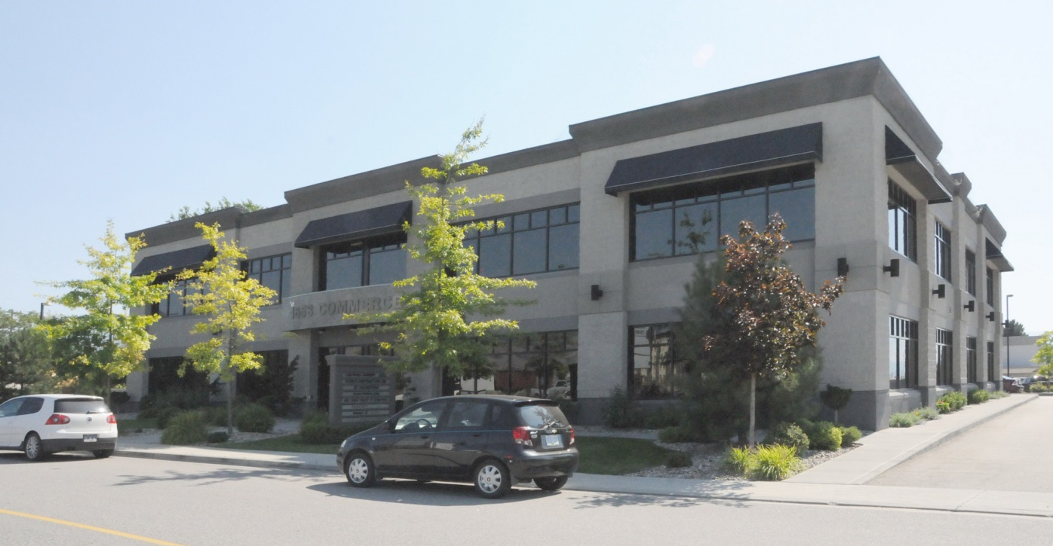

- 1910 sf of Class A fully finished corner office in newer strata building
- Featuring high-end interior design with efficient layout
- Excellent access off Highway 97 N.
- Includes five reserved parking stalls (limited common property) in addition to 15 common stalls for visitors
- Interior includes numerous offices, boardroom, kitchen and bathrooms
AVAILABLE FOR LEASE & SALE:

Suite | Approx. Size (s.f.) | Base Rent (per s.f. per year) | Est. Triple Net (per s.f. per year) | Total Rent (per month) | Additional Costs
103 | 1910 | $19.00 | $8.41 | $4362 | G.S.T. & Util.

103 is also available for sale for $630,000 ($329/SF)

FOR MORE INFORMATION PLEASE CONTACT:

executive summary:

ZoNING | I1 - Business Industrial
STRATA FEES | $636.64/mo + GST
LegaL ADDRESS  PROPERTY TAXES | Strata Lot 3, Plan KAS2910, DL 125, ODYD  2016: $8421
COMMON AREA AMENITIES | The building features a common entrance on the North and South sides of the building. The building is serviced by an elevator as well as two staircases and has a handicapped accessible washroom on the main floor.

FLOORPLAN:

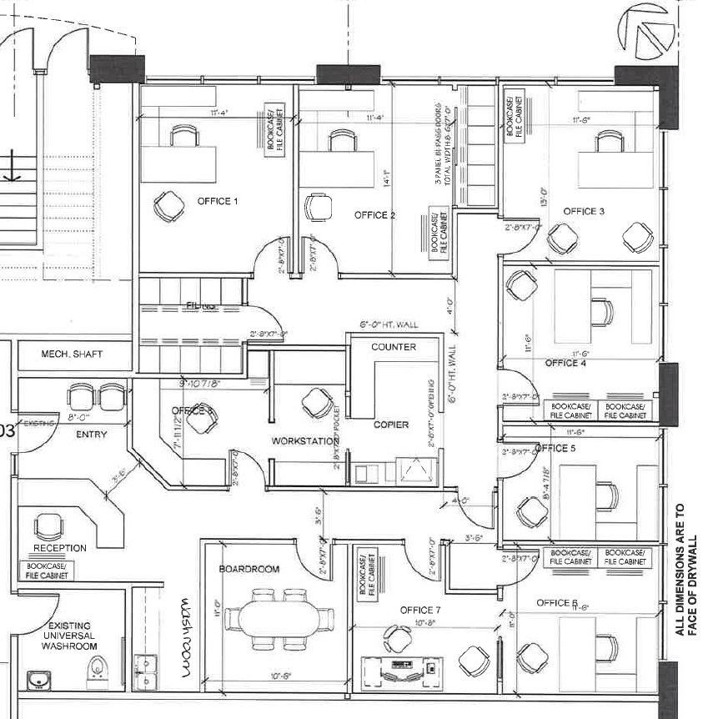

PARKING PLAN:

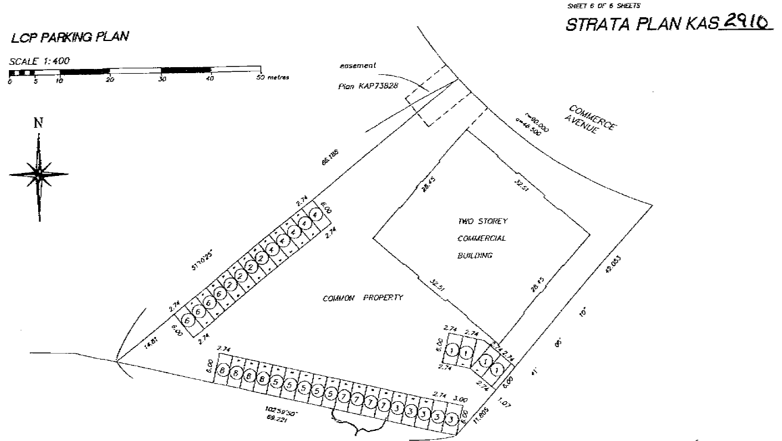
COMMON
PARKING
HERE
RESERVED PARKING HERE

INTERIOR PHOTOGRAPHS:

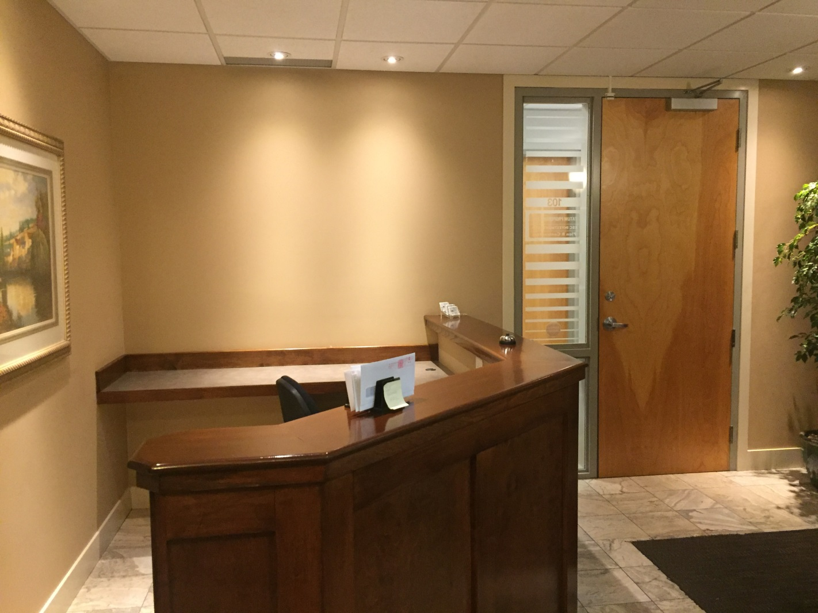

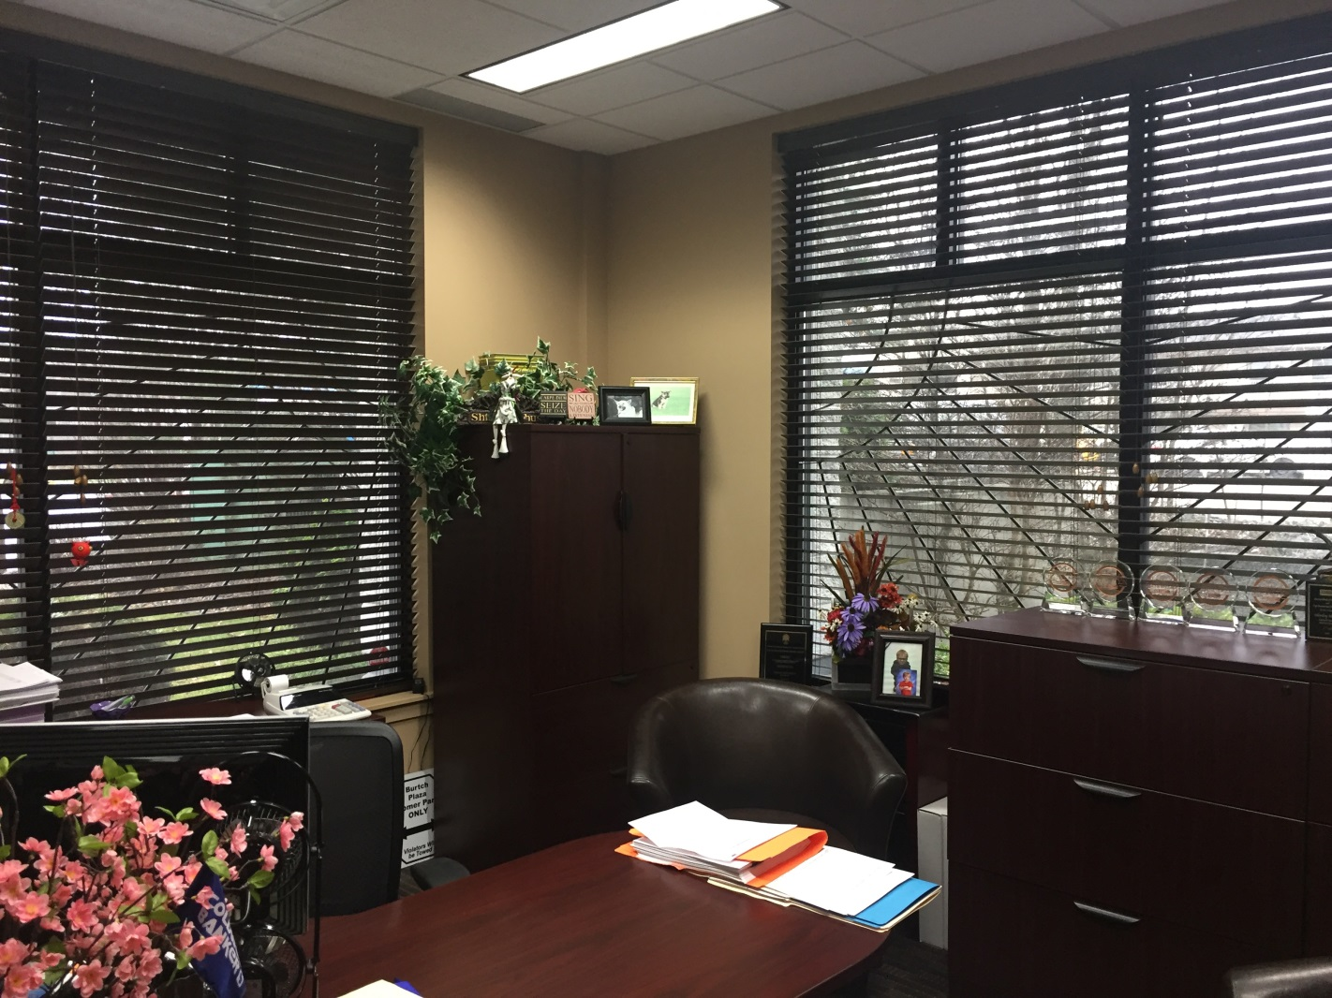
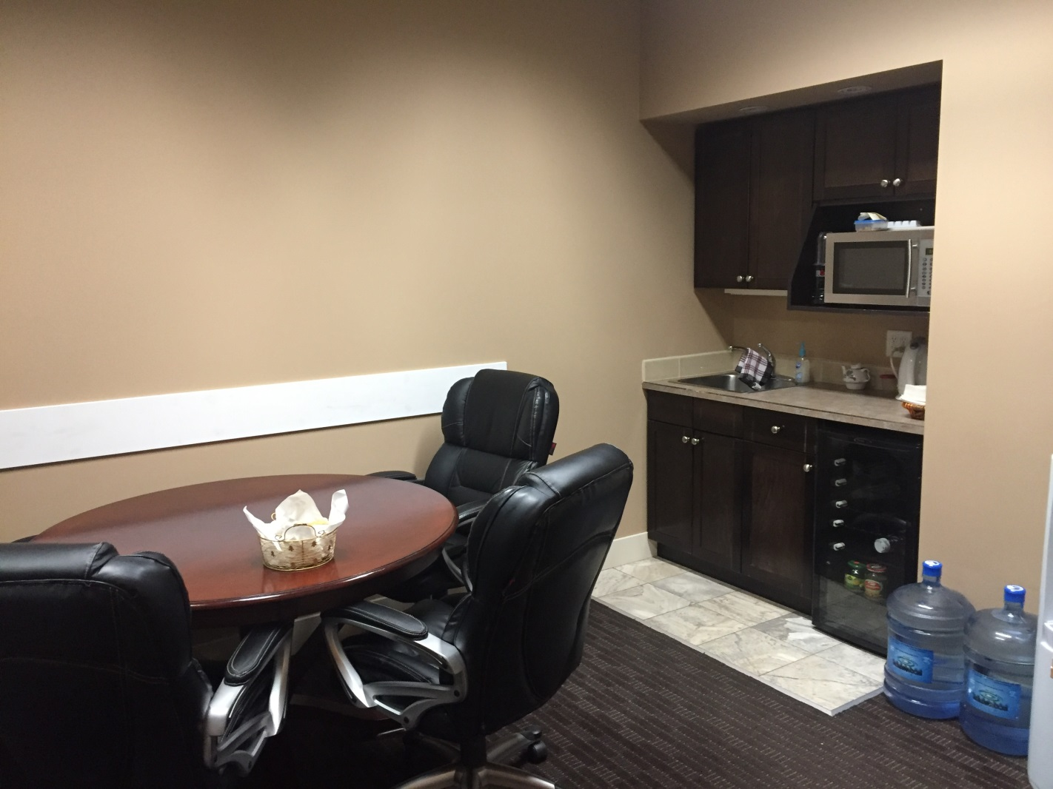

STRATA BUDGET:

